Was this zoologist punished for telling school kids politically incorrect facts about polar bears?

*Opinion: Dr. Susan Crockford describes her expulsion from the University of Victoria as 'an academic hanging without a trial, conducted behind closed doors'*

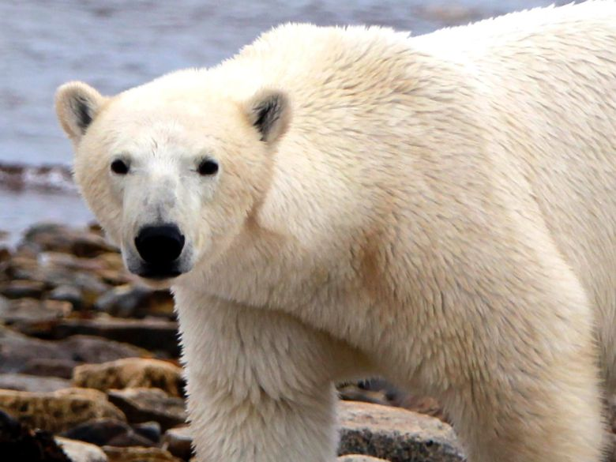

Zoologist Dr. Susan Crockford says that, contrary to the claims of environmental activists, polar bears are currently thriving and are at no risk of extinction from climate change.*Postmedia*

[](https://business.financialpost.com/author/specialfp)

[Special to Financial Post](https://business.financialpost.com/author/specialfp)

October 16, 2019 6:30 AM EDT

**Last Updated**

October 16, 2019 10:18 AM EDT

Filed under

* FP Comment

Comment

[Facebook](https://www.facebook.com/sharer/sharer.php?u=https%3A%2F%2Fbusiness.financialpost.com%2Fopinion%2Fwas-this-zoologist-punished-for-telling-school-kids-politically-incorrect-facts-about-polar-bears)

[Twitter](https://twitter.com/intent/tweet?text=Was%20this%20zoologist%20punished%20for%20telling%20school%20kids%20politically%20incorrect%20facts%20about%20polar%20bears%3F&url=http%3A%2F%2Fbusiness.financialpost.com%2Fwcm%2Fe32cb561-104b-42c5-ac15-c6edf18d2ad7&related=financialpost,fullcomment&via=nationalpost)

[Reddit](https://www.reddit.com/submit?url=https%3A%2F%2Fbusiness.financialpost.com%2Fopinion%2Fwas-this-zoologist-punished-for-telling-school-kids-politically-incorrect-facts-about-polar-bears&title=Was+this+zoologist+punished+for+telling+school+kids+politically+incorrect+facts+about+polar+bears%3F)

[Email](mailto:?subject=Financial%20Post%3A%20Was%20this%20zoologist%20punished%20for%20telling%20school%20kids%20politically%20incorrect%20facts%20about%20polar%20bears%3F&body=I%20wanted%20to%20share%20a%20story%20with%20you%20from%20Financial%20Post%3A%0A%0AWas%20this%20zoologist%20punished%20for%20telling%20school%20kids%20politically%20incorrect%20facts%20about%20polar%20bears%3F%0AOpinion%3A%20Dr.%20Susan%20Crockford%20describes%20her%20expulsion%20from%20the%20University%20of%20Victoria%20as%20%27an%20academic%20hanging%20without%20a%20trial%2C%20conducted%20behind%20closed%20doors%27%0Ahttps%3A%2F%2Fbusiness.financialpost.com%2Fopinion%2Fwas-this-zoologist-punished-for-telling-school-kids-politically-incorrect-facts-about-polar-bears%0A)

More

RELATED STORIES

[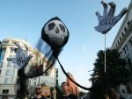](https://business.financialpost.com/opinion/terence-corcoran-net-zero-carbon-is-a-big-nothing-nobody-has-a-clue-how-to-achieve-it)

[Terence Corcoran: Net-zero carbon is a big nothing — nobody has a clue how to achieve it](https://business.financialpost.com/opinion/terence-corcoran-net-zero-carbon-is-a-big-nothing-nobody-has-a-clue-how-to-achieve-it)

[Terence Corcoran: The UN's Greta Thunberg climate gamble offers up a child who's mastered the art of regurgitating political slogans](https://business.financialpost.com/opinion/terence-corcoran-the-uns-greta-thunberg-climate-gamble-offers-up-a-child-whos-mastered-the-art-of-regurgitating-political-slogans)

[Joe Oliver: Here’s a truth few dare to utter: Canada will benefit from climate change](https://business.financialpost.com/opinion/joe-oliver-heres-a-truth-few-dare-to-utter-canada-will-benefit-from-climate-change)

**By Donna Laframboise**

A world-renowned expert in animal bone identification has lost her position at the University of Victoria (UVic), she believes for telling school kids politically incorrect facts about polar bears.

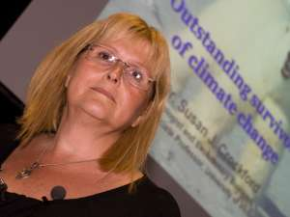

Dr. Susan Crockford at the University of Toronto in 2012. *Dave Thomas/Toronto Sun/QMI Agency files*

Zoologist Dr. Susan Crockford is routinely hired by biologists and archeologists in Canada and abroad to identify the remains of mammals, birds and fish. She has helped catalog museum collections, and assisted police with forensic analyses. But UVic students will no longer benefit from her expertise, and her ability to apply for research grants has come to a screeching halt. In May, the Anthropology Department withdrew her Adjunct Professor status, depriving her of a university affiliation.

Crockford describes her expulsion as “an academic hanging without a trial, conducted behind closed doors.” After being renewed unanimously in 2016 for a three-year term, her adjunct status was not renewed the next time around.

Crockford is the author of a popular blog, [polarbearscience.com](https://polarbearscience.com/), as well as five books about these animals. Polar Bear Facts and Myths has been translated into four languages. She says that, contrary to the claims of environmental activists, polar bears are currently thriving and are at no risk of extinction from climate change.

* [Netflix is lying about those falling walruses. It’s another ‘tragedy porn’ climate hoax](https://business.financialpost.com/opinion/netflix-is-lying-about-those-falling-walruses-its-another-tragedy-porn-climate-hoax)
* [Don’t blame melting ice for polar bear attacks. Blame a bear baby boom](https://business.financialpost.com/opinion/dont-blame-melting-ice-for-polar-bear-attacks-blame-a-bear-baby-boom)
* [Polar bears keep thriving even as global warming alarmists keep pretending they’re dying](https://business.financialpost.com/opinion/polar-bears-keep-thriving-even-as-global-warming-alarmists-keep-pretending-theyre-dying)

Informing the public of these plain facts now appears to be unacceptable to UVic. After 15 years, Crockford was advised in May that an internal Appointment Reappointment Promotion and Tenure (ARPT) committee had “voted not to renew your Adjunct Status.” No reasons were provided. Having undergone hip surgery in the interim, Crockford is only now going public.

When contacted by the National Post recently, UVic spokesman Paul Marck refused to say how many people were on the ARPT committee, how many voted against Crockford, or how many were zoologists in a position to make an informed decision about her abilities.

The position of Adjunct Professor is unpaid. In exchange for mentoring students, sitting on thesis committees, and delivering occasional lectures, adjuncts gain official academic standing and full access to library research services. When asked what safeguards ensure that adjuncts can’t be excommunicated merely for expressing unpopular ideas, spokesman Marck declined to respond, citing provincial privacy legislation. In his words, the university doesn’t disclose “information about internal processes. We must respect the privacy rights of all members of our campus community.”

In this case, the university is not protecting Crockford’s right to privacy. Instead, it is using a privacy smokescreen to protect members of a committee who have decided to purge an adjunct professor without reason or explanation.

Absent any other plausible explanation, Crockford has concluded that she was removed in order to suppress views on polar bears and related climate change issues and prevent her from continuing to challenge the high-profile academics who claim polar bear populations are in crisis.

G. Cornelis van Kooten, a UVic professor of economics who also holds a Canada Research Chair in environmental studies, says he is “appalled and distressed” by the Crockford removal. When, he asks, did “universities turn against open debate? There’s now a climate of fear on campus.”

Academia is a “publish or perish” workplace, and Crockford is an accomplished scholar. Last year, she was co-author of a paper published in Science, one of the world’s most prestigious scientific journals. On any campus, the number of professors whose recent work appears in that journal is small. Once again citing privacy concerns, UVic spokesman Marck declined to tell the National Post how many other UVic professors have met this high standard.

Crockford says she isn’t entirely surprised by her expulsion, given her previous ban from the UVic Speakers Bureau. For the better part of a decade, that entity had arranged for her to deliver unpaid lectures to elementary and high school students, as well as to adult community groups. One talk concerned the early origins of domestic dogs. The other was titled Polar Bears: Outstanding Survivors of Climate Change.

There is every indication she was a popular speaker. But in 2017, UVic Speakers Bureau co-ordinator Mandy Crocker advised her of a policy change. The chair of the Anthropology Department now needed to confirm that Crockford was “able to represent the university” when discussing these topics.

Crockford’s 2004 dissertation broke new ground with regard to the mechanisms by which wolves evolved into domestic dogs. UVic awarded her a PhD for that research. Yet 13 years later, Dr. Ann Stahl, as Chair of the Anthropology Department, banned Crockford from telling members of the public about it as a representative of the school.

In April 2017, Stahl advised: “I will not be endorsing your request to be included in the Speakers Bureau roster for 2017-2018.” Admitting that she couldn’t prevent Crockford from speaking elsewhere as a private citizen, Stahl drew the line at her doing so “as a representative of UVic.”

Stahl said she respected “issues of academic freedom,” but Crockford’s talks at schools had “generated concern among parents regarding balance” and that this concern had “been shared with various levels of the university.” Stahl did not respond to a request by the National Post for an interview.

That was the first time Crockford was made aware of any problems. Because no one from the Speakers Bureau or the Anthropology Department has ever advised her of any specific complaint, she was never given an opportunity to defend herself.

The Speakers Bureau draws its volunteers from UVic “faculty, staff, graduate students and retirees.” Prospective speakers complete a form on its website, which says nothing about departmental approval. There is no suggestion that presentations must be balanced, and many appear to be overtly political.

For example, Social Studies associate professor Jason Price currently delivers a lecture titled Education and the Revolution: Climate Change and the Curriculum of Life, to students as young as kindergarten age. Patrick Makokoro, a UVic graduate student, offers a presentation to audiences as young as 10 about social justice.

Dwight Owens, an employee of Ocean Networks Canada, an entity affiliated with UVic, has no scientific training. His BA is in Chinese language and literature. His MA is in educational technology. Nevertheless, under the auspices of the UVic Speakers Bureau, he has been giving talks about ocean chemistry and climate change for years.

The National Post asked UVic spokesman Marck how many people have been forbidden from participating in the Speakers Bureau, and what mechanisms are in place to vet presentations about controversial topics. Marck refused to address either of these matters. Speakers Bureau co-ordinator Crocker also declined to be interviewed.

Current and former UVic faculty members contacted by the National Post aren’t aware of any vetting process. Currently, therefore, there is no evidence that even inexperienced graduate students need permission to “represent the university.” That requirement appears to have been invented solely as a means of silencing the eminently qualified, highly experienced Crockford.

Because her polar bear message conflicts with activist rhetoric, and because activists apparently complained to administrators, her career as an academic researcher has come to an abrupt end.

Jeffrey Foss, a former chair of UVic’s philosophy department, says Crockford has been punished for speaking her own mind about matters of fact, which means she has been denied academic freedom and free speech. “I’m beginning to lose faith and hope in the university system,” he says.

During the time she delivered lectures to elementary school students, Crockford says she was continually “astonished to learn that every single teacher believed that only a few hundred to a few thousand polar bears were left.” She feels duty bound as a scientist to speak up, to point out that the global population is officially estimated to be in the range of 22,000 to 31,000 and may be much higher. “I talk to groups about the adaptive features of polar bears that allow them to survive changes in their Arctic habitat,” she says.

This week, Crockford will begin a five-country European speaking tour. Audiences in Oslo, London, Paris, Amsterdam and Munich will hear about her research, evaluate her arguments, and draw their own conclusions.

The University of Victoria needs to explain why it has allowed an internal committee to secretly purge and thereby punish an internationally-recognized researcher, for no known reason other than the fact that some unknown accusers do not agree with her views.

*Donna Laframboise blogs at BigPicNews.com and is the author of two books about the UN’s climate report generator, the IPCC.*